**GARAGE MANAGEMENT SYSTEM**

By

M.Anagha  
 gmail: nnevvythe@gmail.com

**1. Project Overview**  
  
  
A Garage Management System (GMS) Salesforce project is designed to streamline the operations of a garage by integrating customer relationship management (CRM) with essential functions like vehicle maintenance, inventory management, scheduling, and invoicing. The project leverages Salesforce features such as Sales Cloud, Service Cloud, and custom components built with Apex and Visualforce to manage customer profiles, service requests, and repair schedules. It enables efficient tracking of spare parts inventory, automates invoice generation, and provides insightful reports and analytics for better decision-making. With a focus on improving operational efficiency and enhancing customer experience, the system helps garages manage appointments, communicate with customers, and maintain accurate records, all while offering data-driven insights for continuous improvement.  
  
  
**2. Objectives**

Business Goals:

a. Enhance customer satisfaction by providing a seamless experience.

b. Improveoperational efficiency by automating scheduling, service tracking, and payment processes.

c.Centralize data for better decision-making and reporting.

Specific Outcomes:

a. Implement a digital solutionfor managing customer details, appointments, service records, and billing.

b. Provide real-time insights through reports and dashboards.

c. Automate workflows to reduce manualeffort and errors.

**3. Salesforce Key Features and Concepts Utilized**

* **Custom Objects:** Custom objects are used to create entities specific to the garage's needs, such as "Vehicle," "Service Request," "Repair History," and "Inventory." These objects store relevant data and help manage garage operations efficiently.
* **Custom Tabs:** Custom tabs are created to provide easy access to the custom objects and allow users to view and interact with data like vehicle service records, inventory levels, and repair appointments directly from the Salesforce interface.
* **Lightning App:** A **Lightning App** is used to create a unified and personalized user interface for garage employees, mechanics, and customer service agents. The app brings together relevant components like service schedules, customer profiles, and repair statuses in a clean and intuitive design.
* **Custom Fields:** Custom fields are added to standard or custom objects to capture specific data required by the garage, such as vehicle model, service type, repair cost, and inventory levels. These fields help tailor the Salesforce platform to meet the garage's requirements.
* **Validation Rules:** Validation rules ensure data quality by enforcing specific business logic, such as ensuring that a repair appointment cannot be scheduled without the necessary parts in stock or that the customer’s contact details are complete before creating an invoice.
* **Profiles and Roles:** Profiles define the level of access each user has within Salesforce (e.g., Admin, Mechanic, Customer Service). Roles help manage data visibility based on organizational structure, ensuring that employees only see relevant information based on their role (e.g., mechanics can view service requests, but not financial reports).
* **Public Groups:** Public groups are used to facilitate collaboration between users. For example, a "Mechanics" group can be created to manage communication and coordination for service jobs, or a "Sales Team" group can track customer interactions and service bookings.
* **Flows:** Flows are automated processes that guide users through tasks like booking a service appointment, checking inventory, or generating invoices. These flows ensure consistency and reduce manual errors, streamlining the customer experience and internal processes.
* **Apex Triggers:Apex triggers** are used to implement complex business logic, such as automatically sending email notifications when a service request is completed or updating inventory quantities when a part is used in a repair.
* **Reports and Dashboards:Reports and Dashboards** offer insights into garage performance, such as the number of service requests completed, revenue generated, or parts usage. These visualizations help management make informed decisions and track business growth over time.

**4. Detailed Steps to solution design**

Step 1: Creatingthe Developer Account  
 1. Sign Up at SalesforceDeveloper Signup.  
 2. Fill in details: Name, email, role as 'Developer', and company as 'College Name'.   
 3. Username format: username@organization.com.   
 4. Activate the account through the email link.

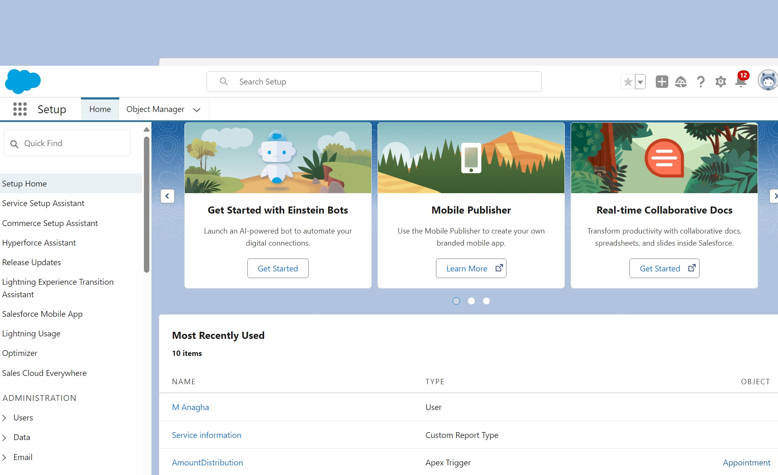

Step 2: Creating Custom Objects   
  
  
1. To Navigate to Setup page:Click on gear icon ? click setup.  
2. To createan object: From the setuppage > Clickon Object Manager> Click on Create > Click on Custom Object.   
3. On Custom object definingpage: Enter the label name, plural label name, click on Allow reports, Allow search.  
4. Click on Save. For our project we need to create four objects  
● CustomerDetails: Text-basedcustomer names with search and report options.   
● Appointment: Auto-numbering system with fields like appointment name and display format.   
● Service Records: Auto-numbered service records with fields for tracking service status.  
● BillingDetails & Feedback: Auto-numbered billing recordswith fields for payment tracking and feedback.  
  
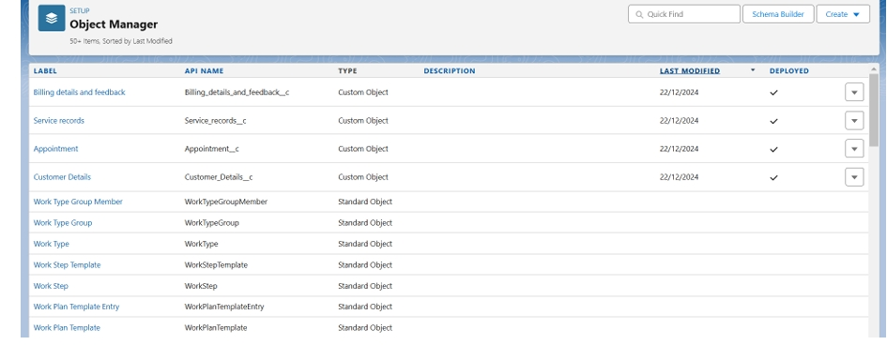

Step 3: Custom Tabs   
  
a. Custom tabs for Customer Details, Appointments, Service Records, and BillingDetails & Feedback.  
b. Tabs are displayed for easy navigation and user access.  
I followed these 4 steps to create all requiredcustom tab  
(i) Go to setup page >>type Tabs in Quick Find bar >>click on tabs >> New (under custom object tab).  
(ii) Select Object(Customer Details)>> Select the tab style >> Next (Add to profiles page) keep it as default>> Next (Add to CustomApp) uncheck the include tab.   
(iii) Make sure that the Appendtab to users' existing personalcustomizations is checked.   
(iv) Click save.  
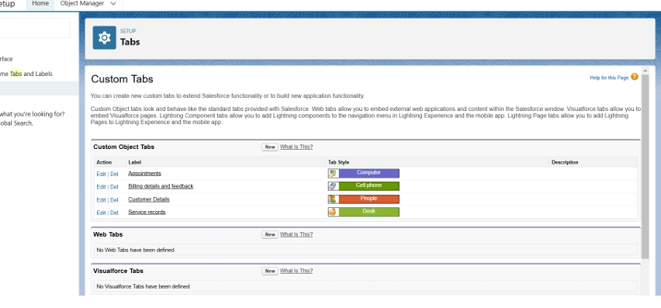

Step 4: Building the Lightning App

1. Name: Garage Management Application.   
2. Navigation Items: Customer Details, Appointments, Service Records, Billing,Reports, and Dashboards.   
3. User Profiles: Assign access to the System Administrator role.   
To create a lightningapp page:   
1. Go to setuppage >> search “app manager” in quick find >> select “app manager” >>click on New lightning App.   
2. Fillthe app name in app details as Garage Management Application >> Next >> (App option page) keep it as default >> Next >> (Utility Items) keep it as default >> Next.   
3. To Add Navigation Items   
4. Select the items (Customer Details,Appointments, Service records, Billing details and feedback, Reportsand Dashboards) from the searchbar and move it usingthe arrow button >> Next.   
5. To Add User Profiles: Searchprofiles (System administrator) in the searchbar >> clickon the arrow button >> save & finish.   
  
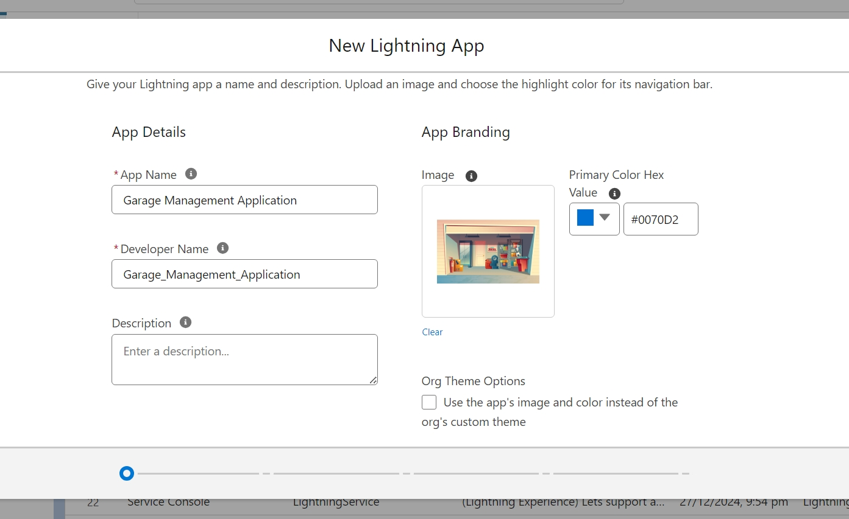

Step 5: Creating Custom Fields

a. Customer Details: Phone and email fields.

1. To create fields in an object:

● Go to setup >> click on Object Manager >> type object name(Customer Details) in search bar >> click on the object.   
● Now click on "Fields & Relationships" >> New   
● Select Data Type as a "Phone"   
● Click on next.   
● Fill the Above as following:   
 Field Label: Phone number   
 Field Name: gets auto generated   
● Click on Next >> Next >> Save and new.

2. To create another fields in an object:   
 ● Go to setup >> click on Object Manager >> type object name (Customer Details) in search bar >> click on the object.   
 ● Now click on "Fields & Relationships" >> New   
 ● Select Data type as a "Email" and Click on Next   
 ● Fill the Above as following:   
 Field Label: Gmail   
 Field Name: gets auto generated   
 ● Click on Next >> Next >> Save and new.  
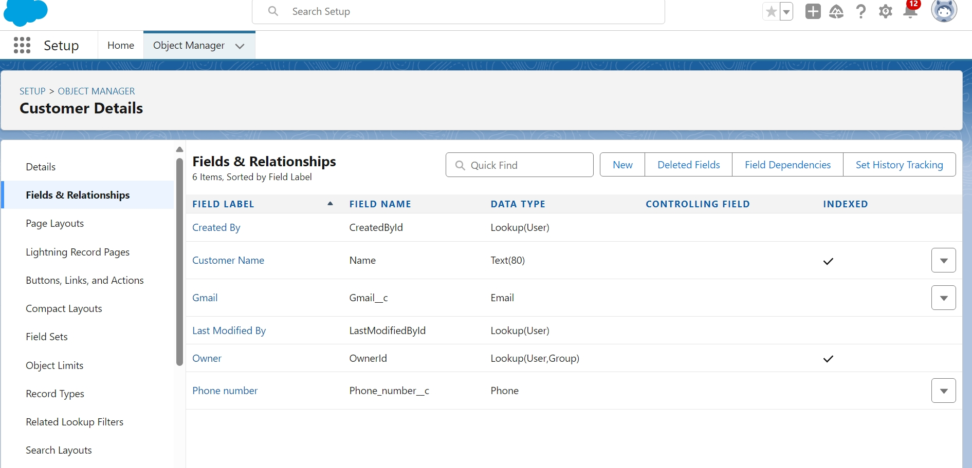

b. Lookup Fields: Link Appointments to Customers, ServiceRecords to Appointments, and Billing Details to Service Records.   
  
c. PicklistFields: Service status(Started, Completed) and payment status(Pending, Completed).   
  
d. Formula Fields: Calculate service date from createddate.   
   
e. Text Fields: Vehiclenumber plate (10 characters, unique)and customer feedbackrating (1 character). Appointments - all fields & relationship:

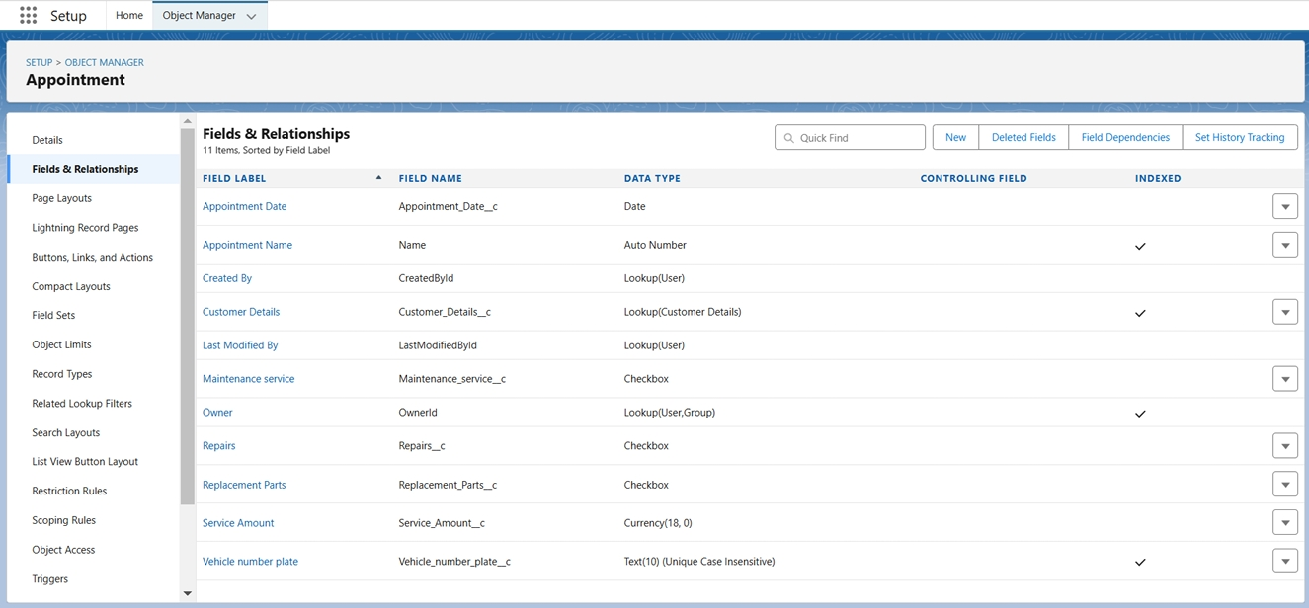

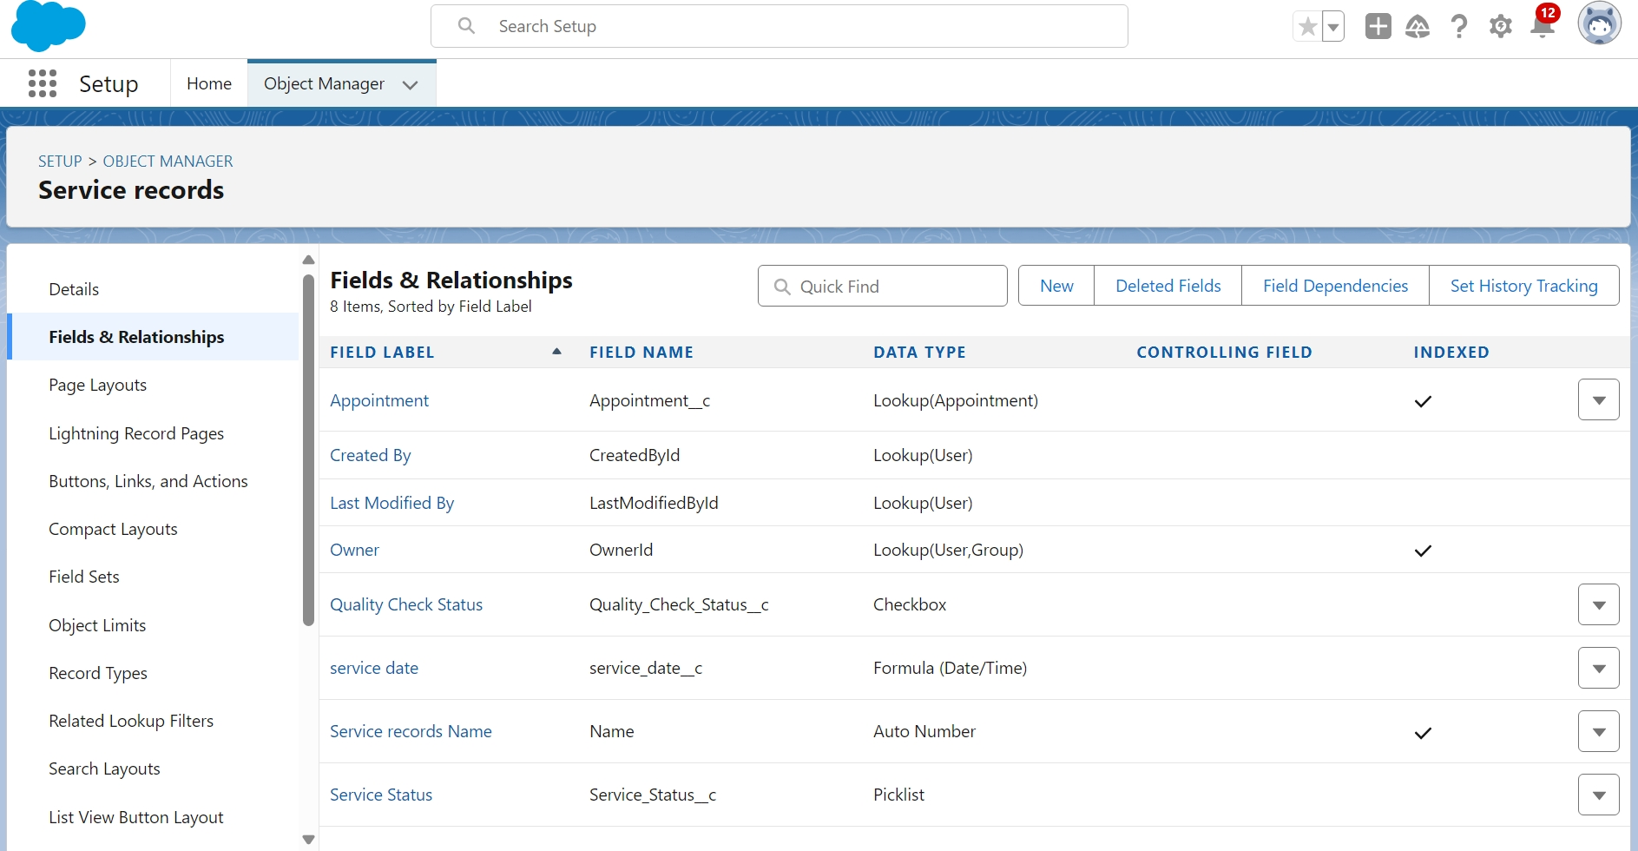

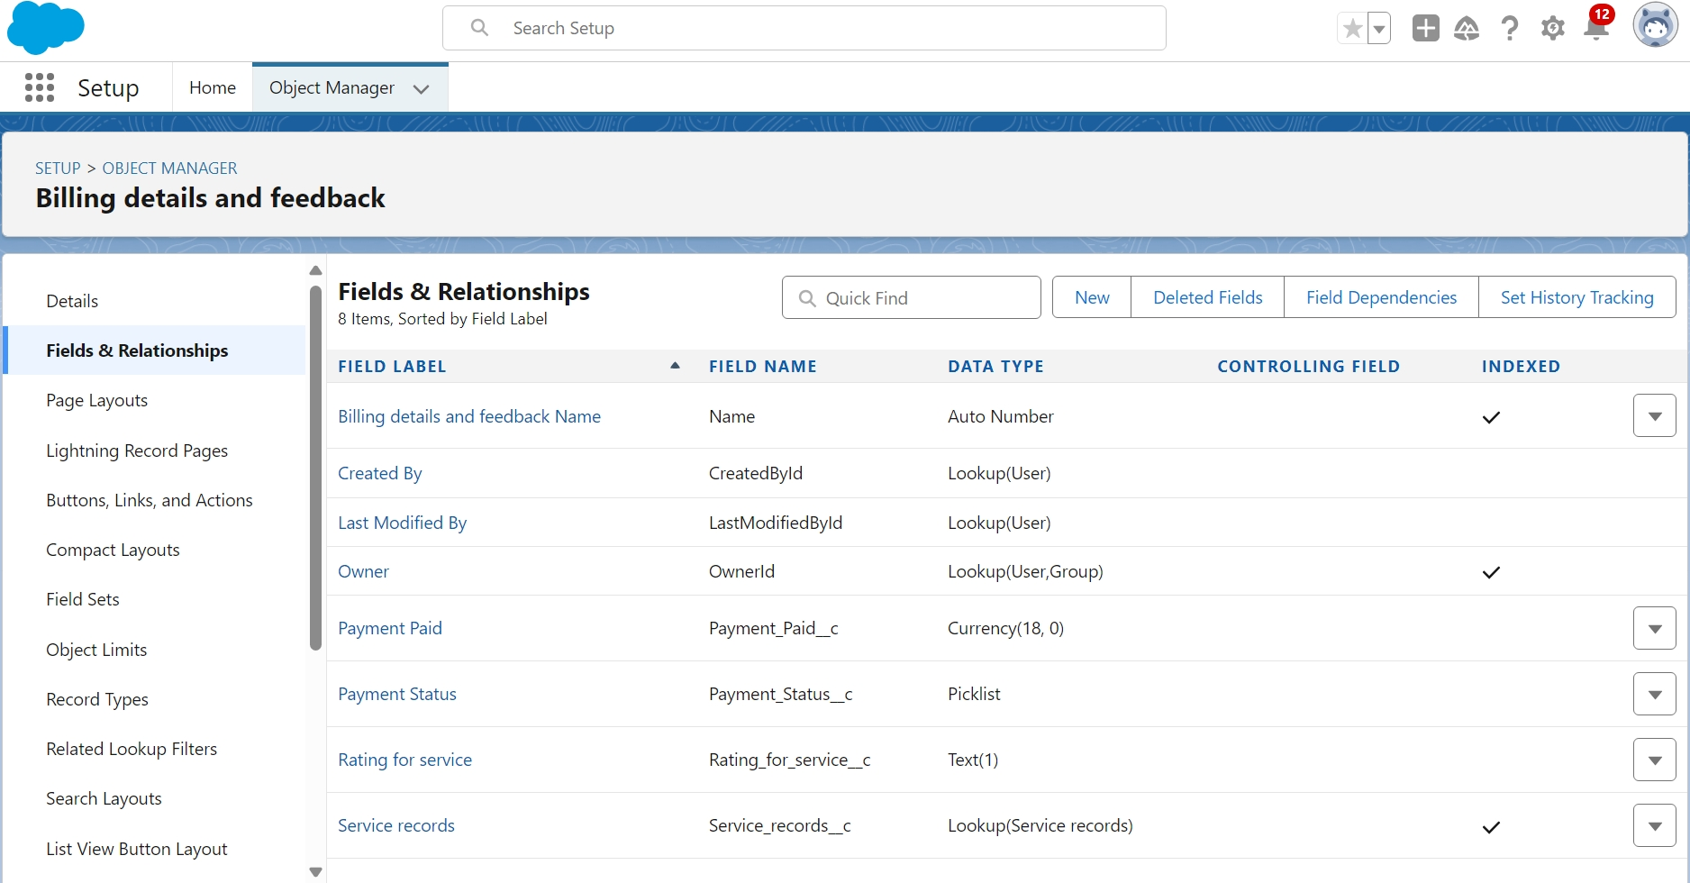

Step 6: Validation Rules Validation rules are applied when a user tries to save a record and are used to check if the data meets specified criteria.If the criteria are not met, the validation rule triggers an error messageand prevents the user from saving the record until the issues are resolved.

a. Vehicle NumberPlate: Must followa format (e.g.,MH12AB1234).   
To create a validation rule to an Appointment Object

1. Go to the setup page >> click on objectmanager >> From drop down click edit for Appointment object.   
2. Click on the validation rule >> click New.   
3. Enter the Rule name as “ Vehicle ”.   
4. Insert the Error Condition Formula as : - NOT(REGEX( Vehicle_number_plate c , "[A-Z]{2}[0-9]{2}[A-Z]{2}[0-9]{4}")).   
5. Enter the Error Message as “Please enter vaild number ”, select the Error location as Field and selectthe field as “Vehicle numberplate”, and click Save.   
  
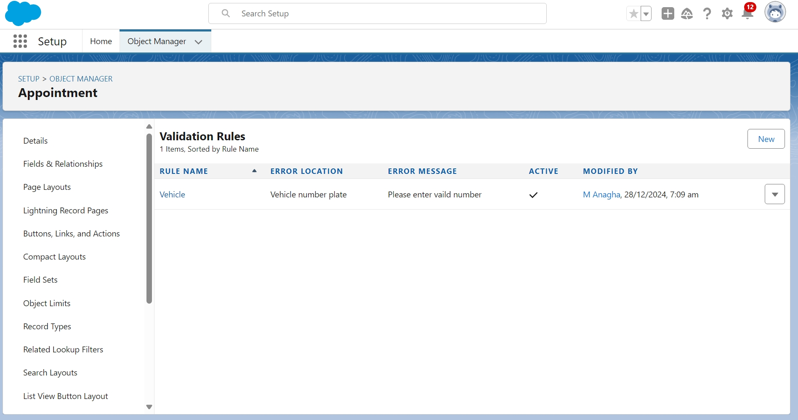

● Service Status: Must be set to "Completed" beforerecord can be saved.   
● Rating: Customerservice rating must be between1 and 5.   
  
 To create a validation rule to an Billing details and feedback Object   
  
1. Go to the setup page >> clickon object manager>> From drop down clickedit for Billing details and feedback object.   
2. Click on the validation rule >> click New.   
3. Enter the Rule name as “ rating_should_be_less_than_5”.   
4. Insert the Error Condition Formula as : - NOT( REGEX( Rating_for_service c , "[1-5]{1}"))   
5. Enter the Error Message as “rating should be from 1 to 5”, select the Error location as Field and select the field as “Ratingfor Service”, and click Save.

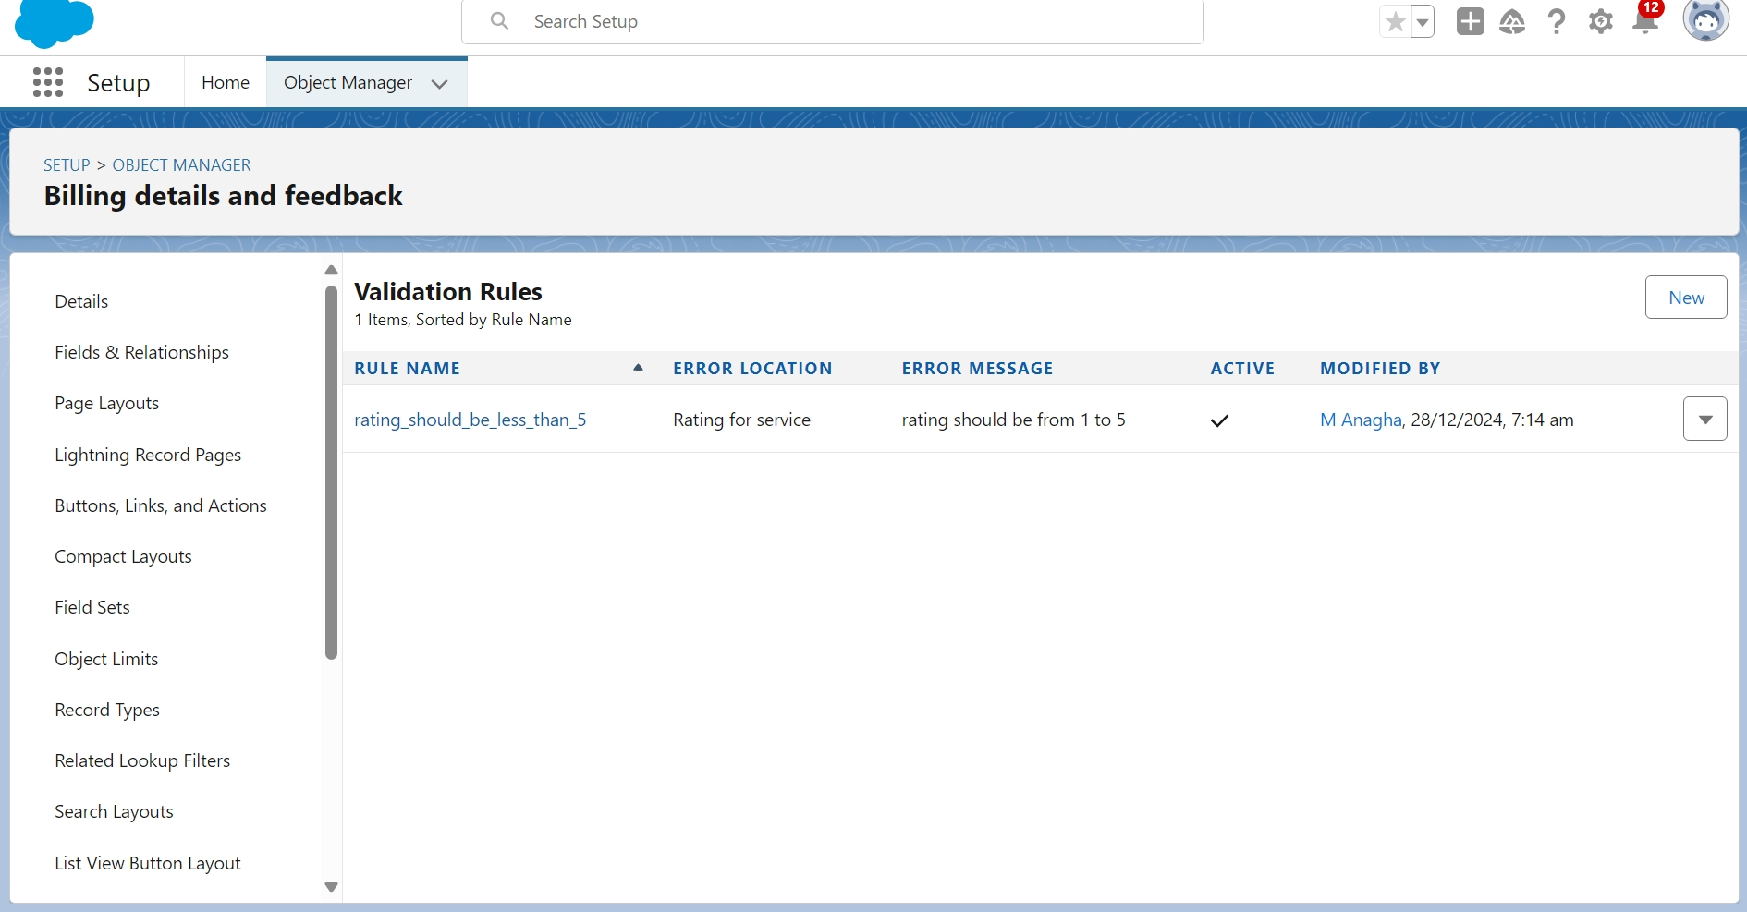

Step 7: Duplicate Rules

● MatchingRule: Checks Gmail and phone number to identifyduplicate customer details. To create a matching rule to an Customer details Object

1. Go to quickfind box in setup and search for matching Rule.   
2. Click on matching rule >> click on New Rule.   
3. Select the objectas Customer detailsand click Next.   
4. Give the Rule name : Matching customer details   
5. Unique name : is auto populated   
6. Define the matching criteria as   
 Field Matching Method   
   
 a. Gmail exact

b. Phone Number exact

8. Click save.   
 9. After Saving Click on Activate. Matching Method Exact Exact

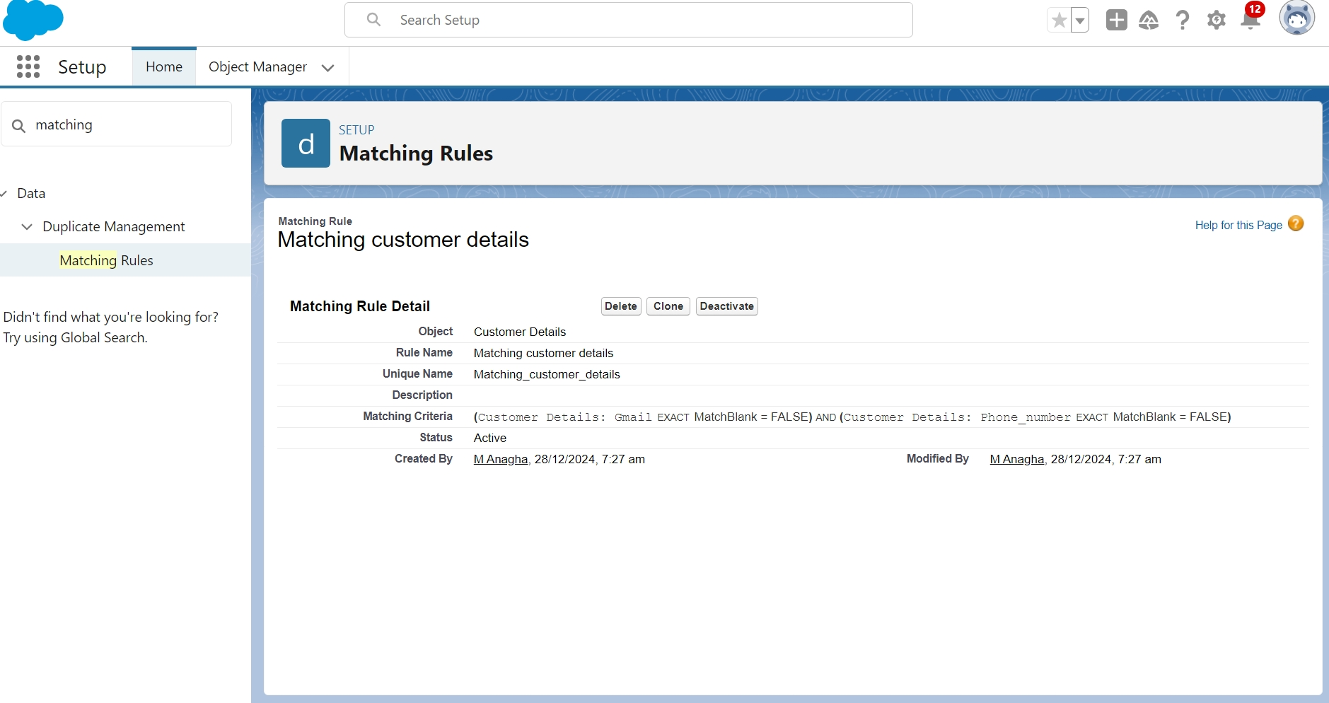

● DuplicateRule:

Prevents duplicate customer records. To create a Duplicaterule to an Customer details Object

1. Go to quick find box in setup and searchfor Duplicate rules.   
2. Click on Duplicate rule >> click on New Rule >> select customer details object.   
3. Give theRulenameas:CustomerDetailduplicate   
4. Scroll a little in Matchingrule section   
5. Select the matchingrule : Matching customerdetails   
6. And Click on save.   
7. After saving the Duplicate Rule, Click on Activate.

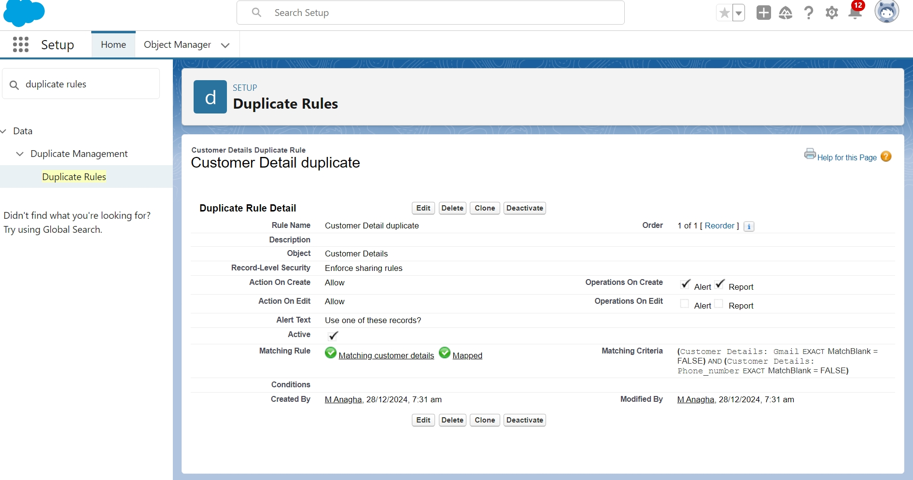

Step 8: Profiles

● ManagerProfile: Access to all customobjects with extendedsession time and password settings.  
● Sales Person Profile: Limited accessto objects with tailored permissions.

Step 9: Roles and Role Hierarchy A role in Salesforce defines a user's visibility access at the record level. Roles may be used to specify the types of access that people in your Salesforce organization can have to data. Simply put, it describes what a user could see within the Salesforce organization.

a. Manager Role:Directly under the CEO.

Creating ManagerRole:

1. Go to quick find >> Search for Roles >> click on set up roles.   
2. Click on ExpandAll and click on add role under whom this role works.   
3. Give Label as “Manager” and Role name gets auto populated. Then click on Save.

b.. Sales Person Role: Reports to the Managerrole.

Creating anothertwo roles under manager

1. Go to quick find >> Search for Roles >> click on set up roles.   
2. Click plus on CEO role,and click add role undermanager.   
3. Give Label as “sales person” and Role name gets auto populated. Then click on Save  
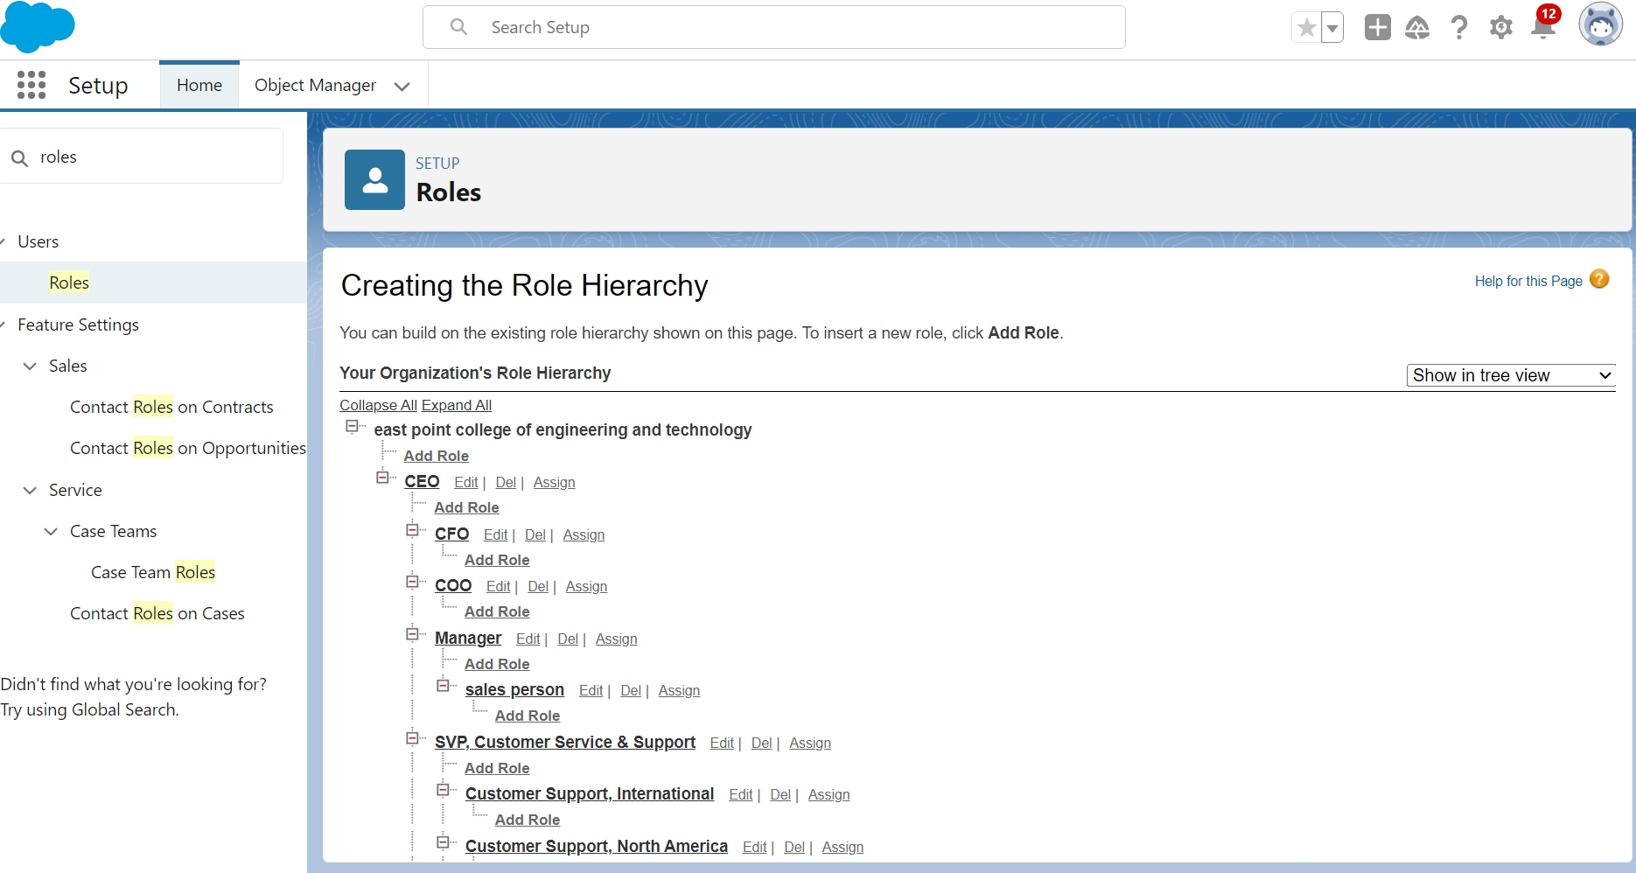

Step 10: Users A user is anyone who logs in to Salesforce. Users are employee sat your company, such as sales reps, managers, and IT specialists, who need access to the company's records. Every user in Salesforce has a user account. The user accountidentifies the user, and the user accountsettings determine what features and records the user can access.   
  
a. ManagerUser: Role as Manager,Profile as Manager, Salesforce license.  
  
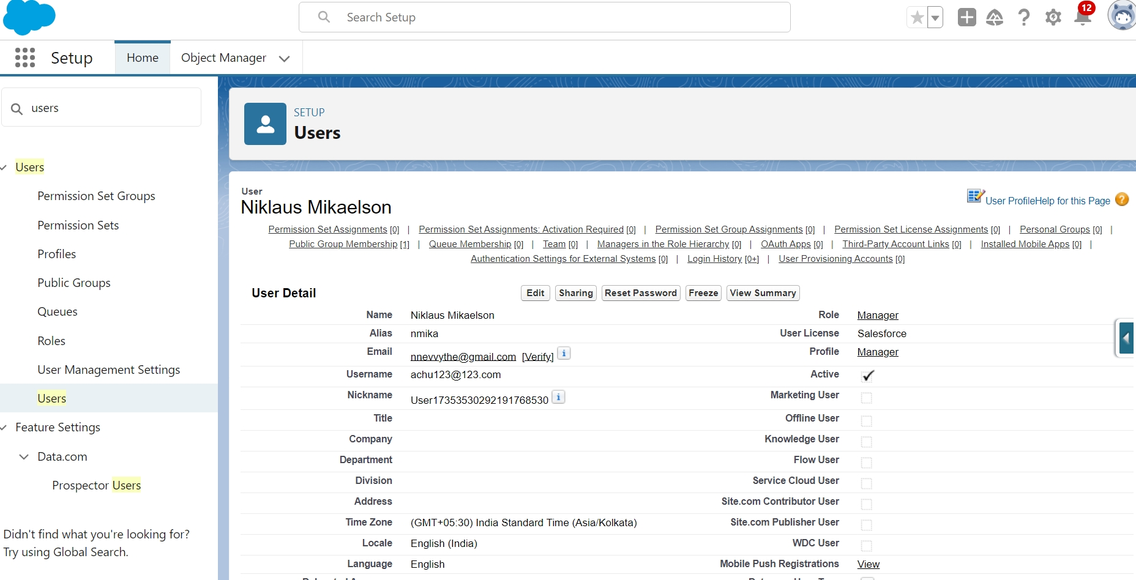

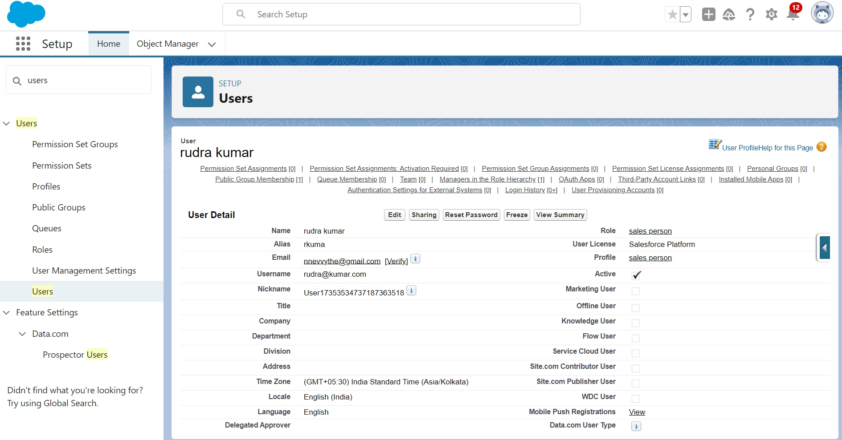

● Sales Person Users: Role as SalesPerson, Profile as Sales Person,Salesforce Platform license.

Step 11: Public Groups Public groups are a valuable tool for Salesforce administrators and developers to streamline user management, data access,and security settings. By creating and using publicgroups effectively, you can maintain a secure and organized Salesforce environment while ensuring that users have appropriate access to the resources they need.

a. Sales Team Group: Containsall Sales Personroles for sharingaccess. Creating New Public Group   
1. Go to setup >> type users in quick find box >> select public groups >> click New.   
2. Give theLabel as“sales team”.   
3. Group name is autopopulated.   
4. Search for Roles.   
5. In Available Membersselect Sales personand click on add it will be moved to selected member.   
6. Click on save.

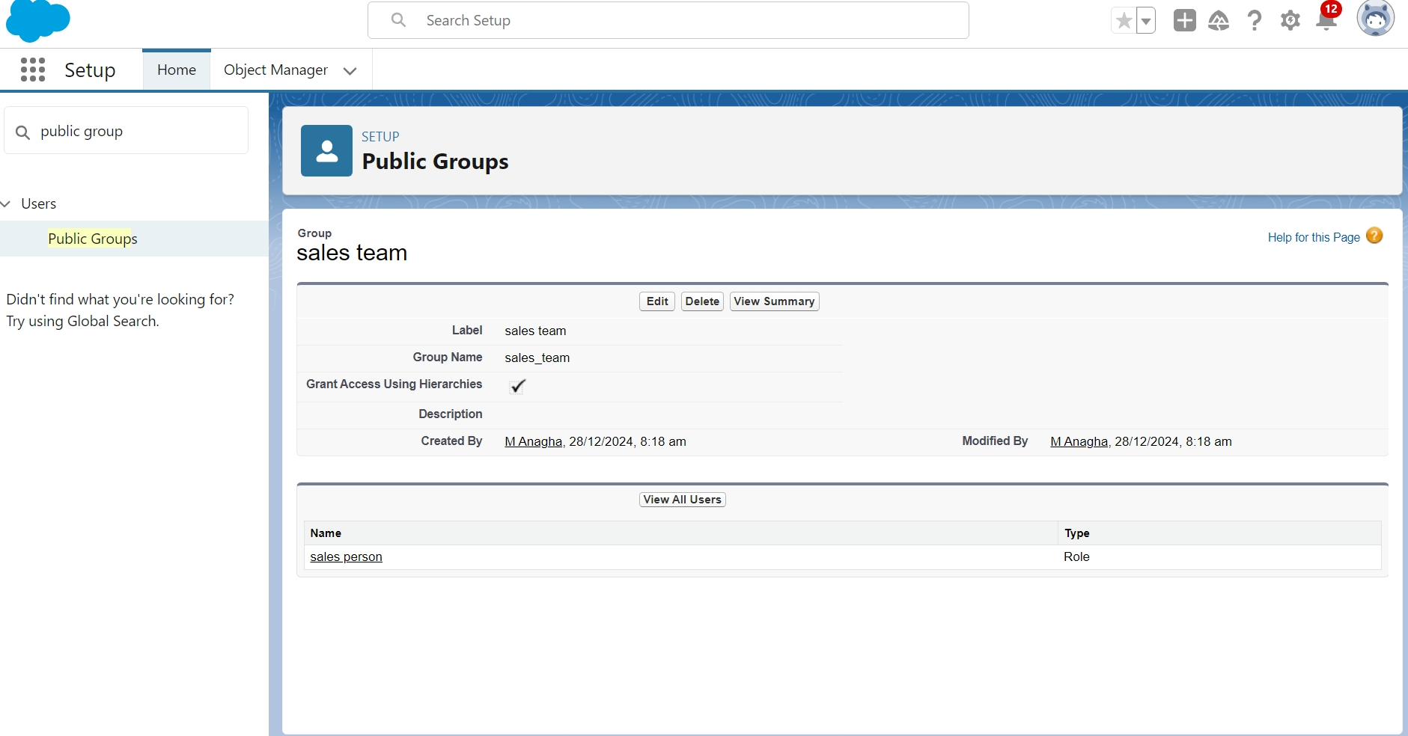

Step 12: Sharing Settings

● Service RecordsOWD: Set to Private.   
● Sharing Rule: Grants read/write access to Manager for Sales Person’s service records.   
CreatingSharing settings   
1. Go to setup >> type users in quick find box >> select Sharing Settings >> click Edit.   
2. Change the OWD setting of the Servicerecords Object to private as shown in fig.   
3. Click on save and refresh.   
4. Scroll down a bit, Clicknew on Service records sharingRules.   
1. Give the Label name as “ Sharing setting”   
2. Rule name is auto populated.   
3. In step 3 : Select which recordsto be shared, members of “ Roles” >> “ Sales person” 4. In step4: sharewith, select“ Roles” >> “ Manager ”   
5. In step 5 : Change the access level to “ Read / write ”.   
 6. Click on save.

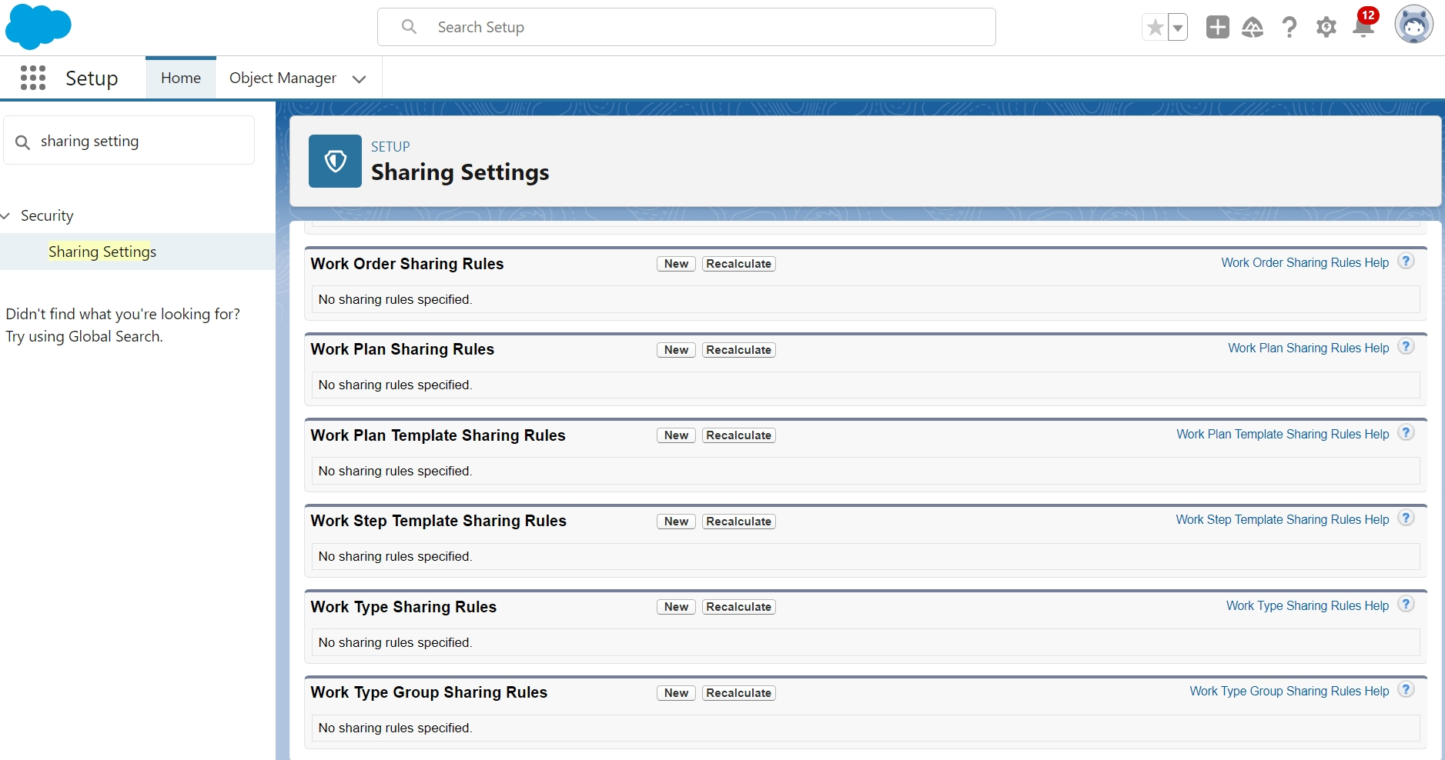

Step 13: Flows In Salesforce, a flow is a powerfultool that allows you to automate business processes, collect and update data, and guide users through a series of screens or steps. Flows are built using a visual interface and can be created withoutany coding knowledge.

a. Record-Triggered Flow: Automatesupdates and emailalerts for billingcompletion.   
b. Under the Record-triggered Flow Click on “+” Symboland In the Drop down List selectthe “Update records Element”  
Email Alert: Sends a "Thank you" message when payments are completed.  
  
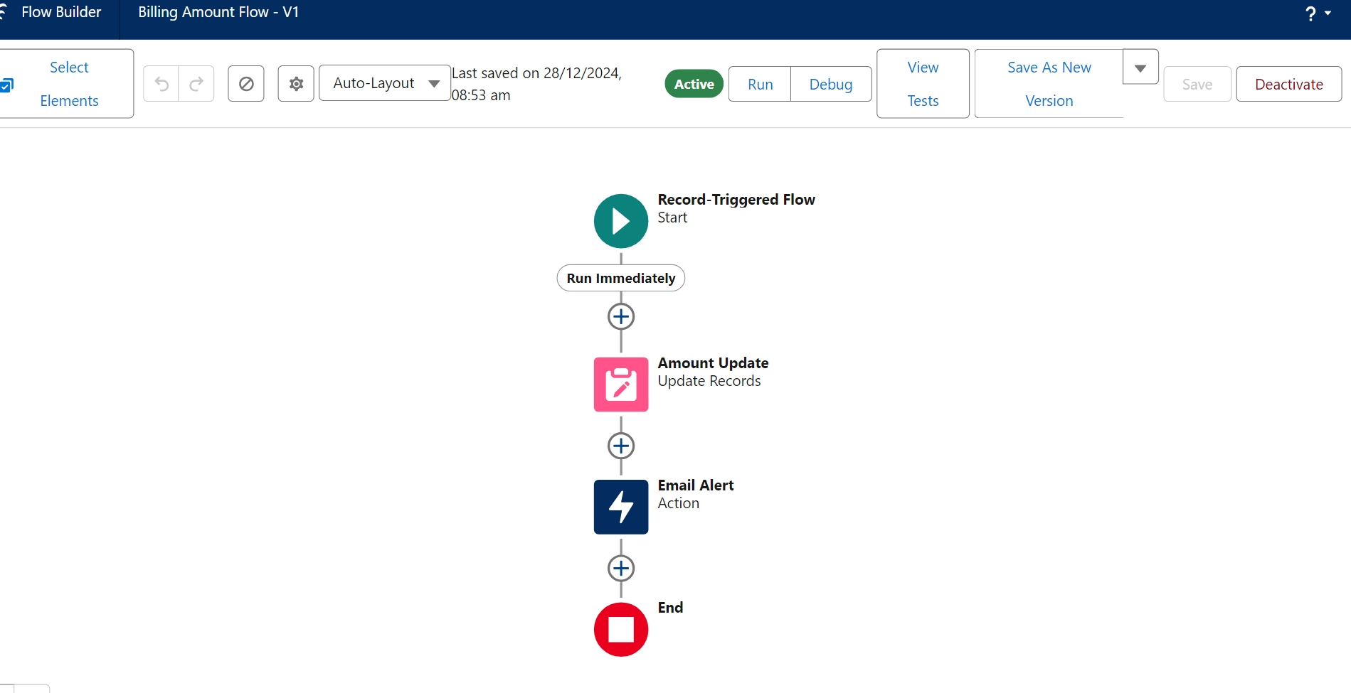

Step 14: Apex Triggers Apex can be invokedby using triggers.Apex triggers enable you to perform custom actions before or after changes to Salesforce records, such as insertions, updates, or deletions.

● HandlerClass (AmountDistributionHandler): Calculates service amounts basedon selected services.  
● Trigger(AmountDistribution): Runs on appointment insertor update to update service amounts.  
  
Step 15: Reports Reports give you access to your Salesforce data. You can examine your Salesforce data in almost infinite combinations, display it in easy-to-understand formats, and share the resulting insights with others. Before building, reading, and sharing reports, review these reporting basics.  
  
● Report Folder: Organize all reports under "Garage Management Folder".  
● Custom Report Type: Combines Customer Details,Appointments, Service Records,and Billing.  
● Reports: Custom report "Service Information Report" with fields for customer, appointment date, service status, and payments. CreateReport   
1. Go to the app >>click on the reports tab   
2. Click New Report.   
3. Select the Category as other reports, search for Service Information, select that report, click on it. And click on start report.   
4. Their outline pane is openedalredy, select the fields that mentioned below in column section.   
a. Customer name b. Appointment Date c. Service Status d. Payment paid   
5. Remove the unnecessary fields.   
6. Select the fieldsthat mentioned belowin GROUP ROWS section. i. Rating for Service   
7. Select the fieldsthat mentioned belowin GROUP ROWS section. i. Payment Status   
8. Click on Add Chart , Select the Line Chart.   
9. Click on save, Give the report Name : New Service information Report   
10. Report unique Name is auto populated.   
11. Select the folder the created and Click on save.

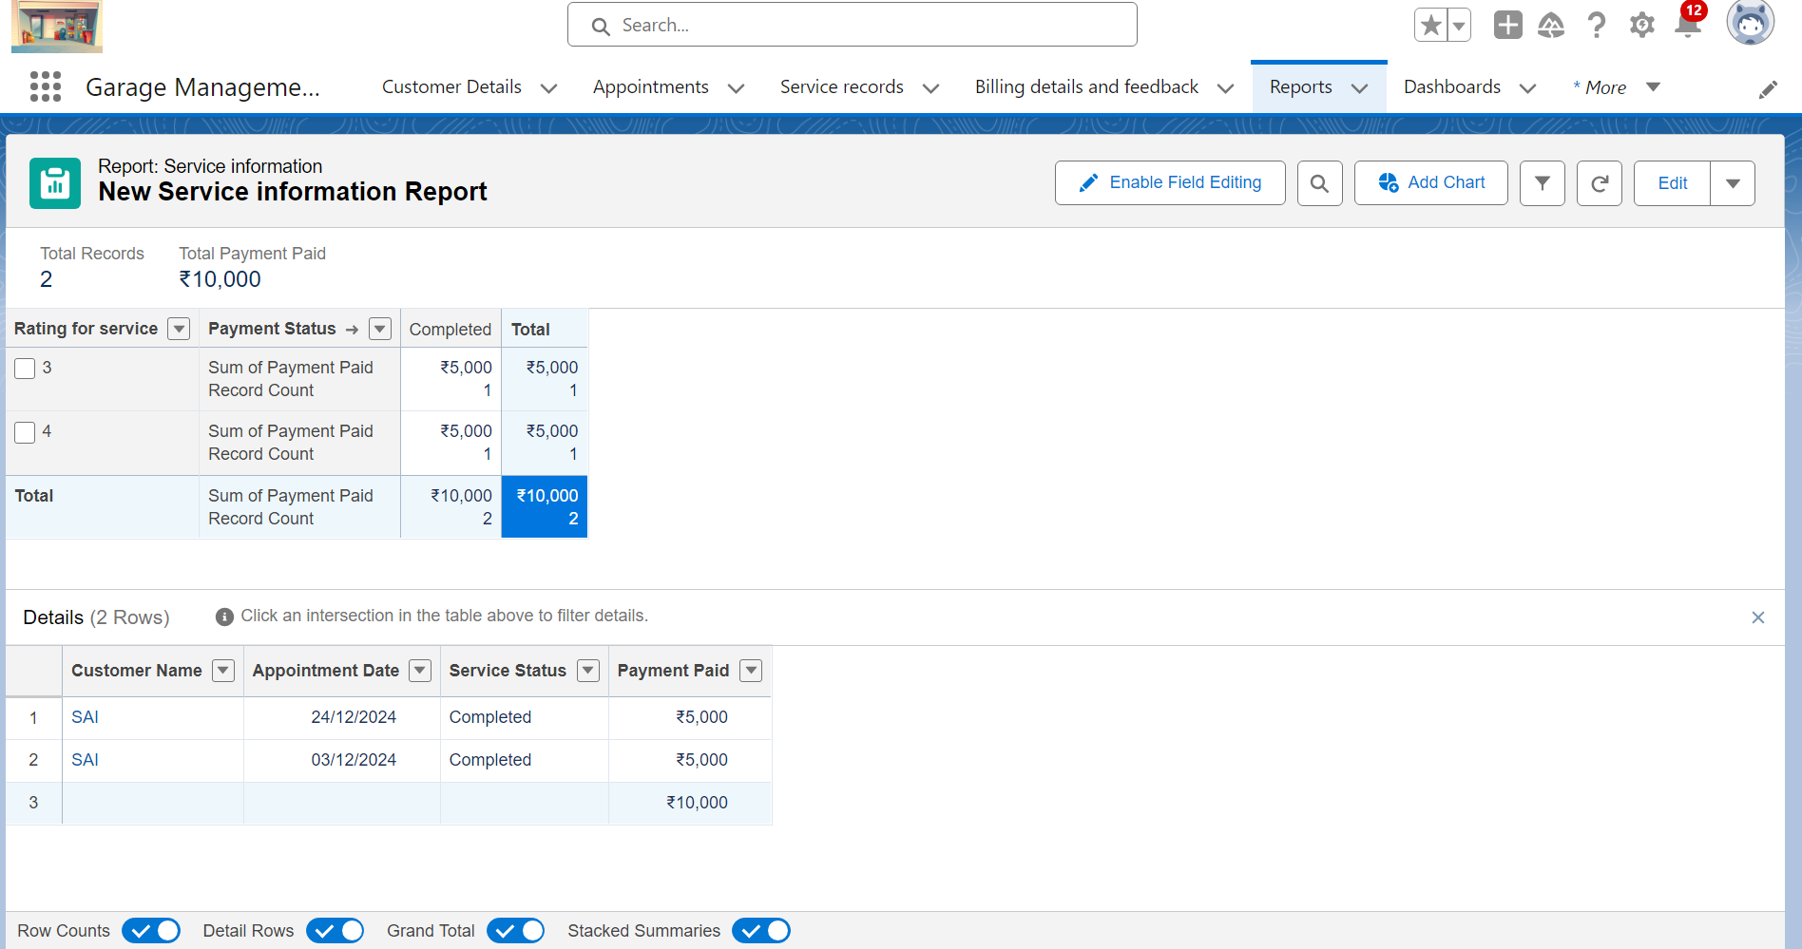  
Step 16: Dashboards   
Dashboards help you visually understand changing business conditions so you can make decisions basedon the real-time data you’ve gathered with reports. Use dashboards to help users identify trends, sort out quantities, and measure the impact of their activities. Before building, reading,and sharing dashboards, review these dashboard basics.   
● DashboardFolder: "Service Rating Dashboard" for organizing dashboards.  
● Dashboard Components: Visualizes service ratings, payment statuses, and operational KPIs.

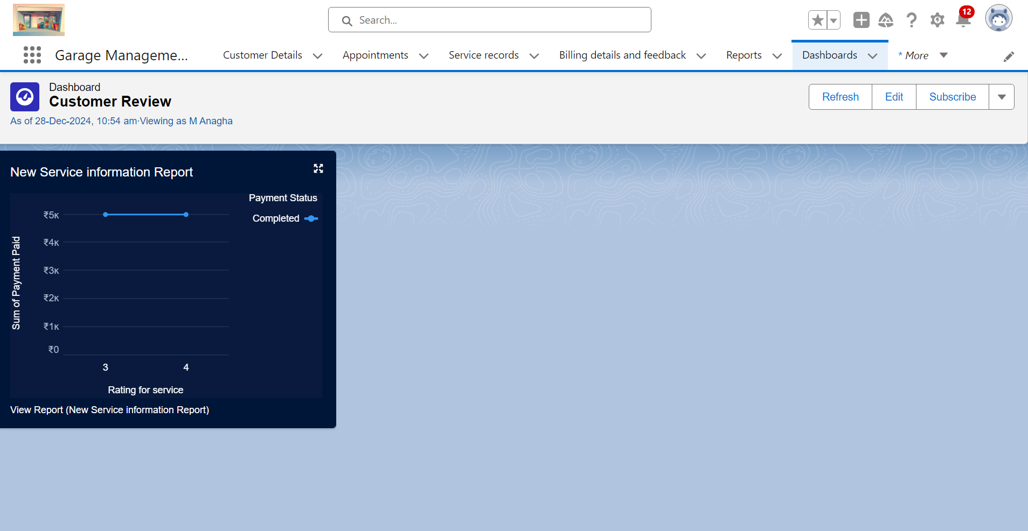

**User Adoption**

In our GarageManagement System we created recordsfor all objects.

Customer Details :  
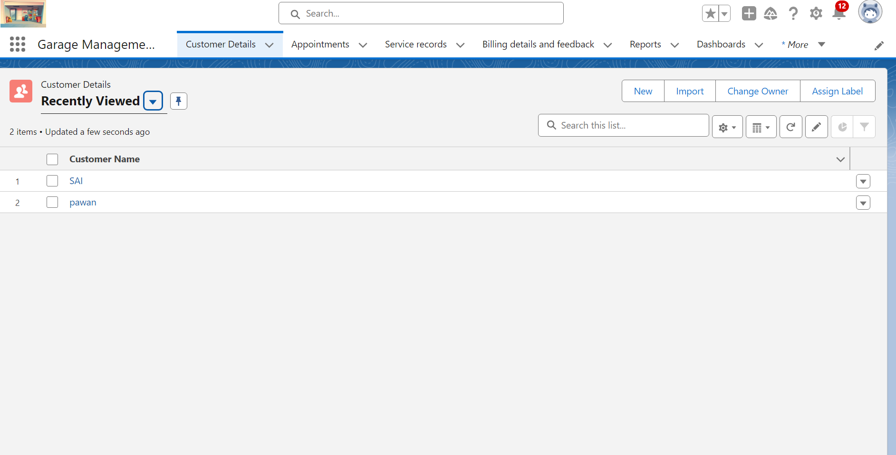  
  
Appointments:

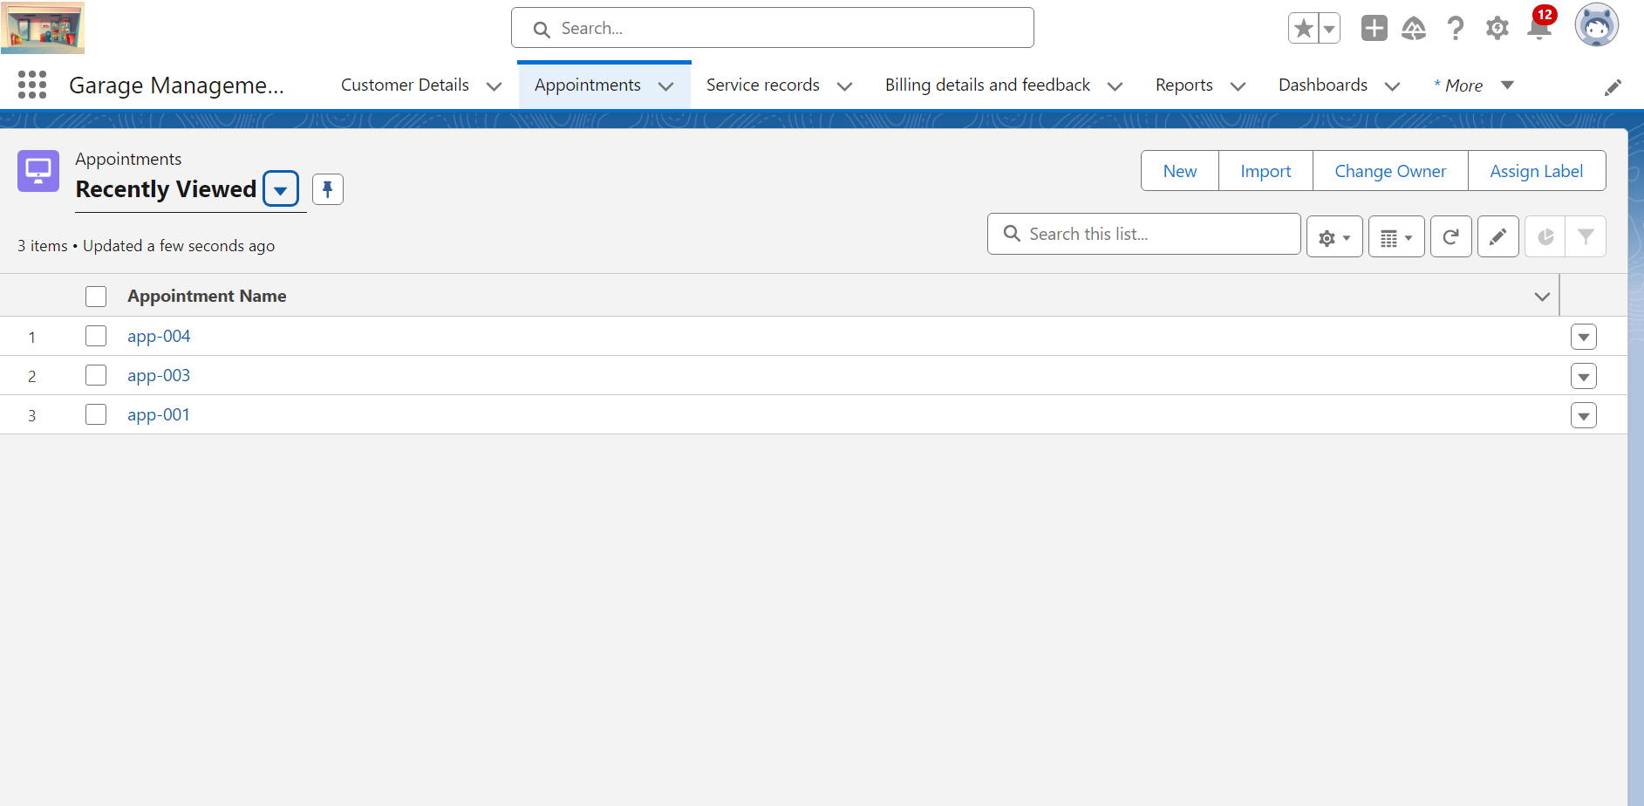

Service Records:  
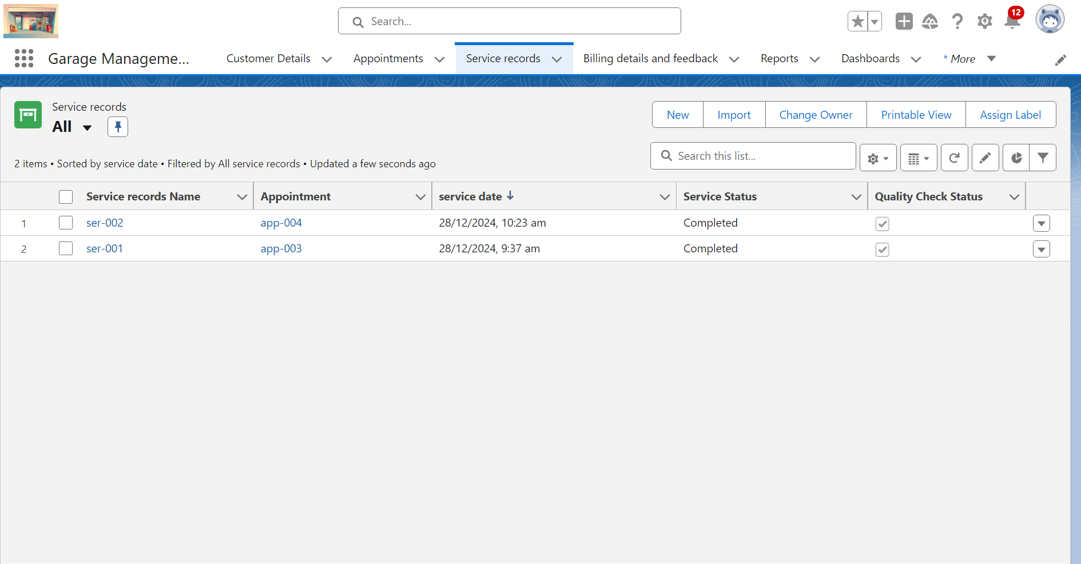

Billing Details and feedback:

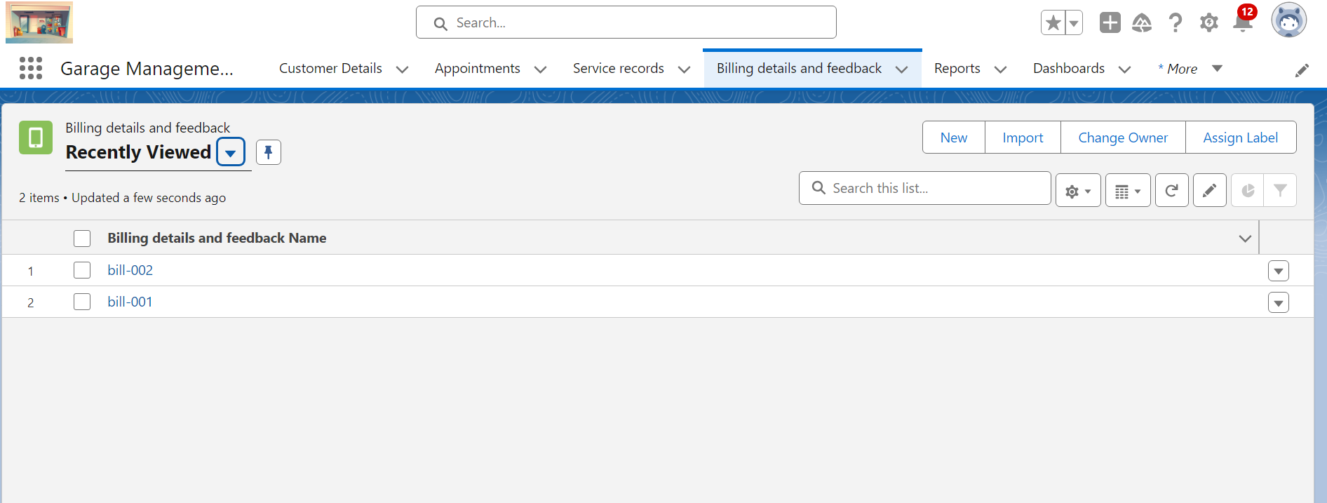

**5. Testing and validation**

a) Unit Testing :Comprehensivetesting of individual components, including Apex classes and triggers, to ensure code accuracy and functionality. Each module will be testedin isolation to detect and fix issues at an early stage.

b) User Interface Testing : Ensure the user interface is user-friendly, responsive, and works on different devices (desktop, tablet, mobile). Validate the functionality of buttons, links, forms, and navigation.

**5. Key Scenarios Addressed by Salesforce in the Implementation Project**

This sectionoutlines the key scenarios that Salesforce addressesin the implementation of the Garage Management System:

1. **Customer Management:** Capture customer details, vehicle history, and send appointment reminders.
2. **Service Scheduling:** Log service requests, assign tasks to mechanics, and manage calendars.
3. **Inventory Tracking:** Monitor parts, alert on low stock, and validate availability for repairs.
4. **Real-Time Updates:** Notify customers and staff of repair progress automatically.
5. **Billing:** Generate accurate invoices and streamline payment processing.
6. **Reports:** Provide dashboards for insights into revenue, service trends, and performance.

**6. Conclusion**

In conclusion, the **Garage Management System (GMS)** project built on Salesforce provides a comprehensive solution to streamline garage operations, enhance customer satisfaction, and improve overall efficiency. By leveraging Salesforce's powerful features like custom objects, flows, validation rules, and dashboards, the system ensures effective management of customer interactions, service scheduling, inventory tracking, and billing. With its automated workflows, real-time updates, and data-driven insights, the GMS not only simplifies daily operations but also supports strategic decision-making for business growth. This project demonstrates how technology can transform traditional garage management into a modern, efficient, and customer-focused process.